**Instituto Politécnico Nacional**

**Escuela Superior de Cómputo**

*Fundamental Analysis of Circuits*

Practice 3: Kirchhoff’s Laws.

Group: 1CV13

Team: 7

Members:

Pastor Martínez Luis Enrique

Partido Terrón Luis Alberto

Pérez Garduño José Emiliano

Professor:

Raúl Santillán Luna

Practice day: September 18, 2017

Delivery day: October 2,2017

**Index:**

1. Objective
2. Introduction
3. Development
4. Calculations
5. Conclusions

**Objective:**

The student will apply ohm´s laws and Kirchhoff’s laws to voltages and currents to the analysis of electric circuits, so that when the practice ends, he will be in possibility of validating and corroborating the calculations obtained by techniques and methods already established, like the next ones:

Kirchhoff ´s law of voltage, in a series of meshes.

Kirchhoff’s law of current, in a series of nodes.

**Introduction:**

***Kirchhoff’s Laws:*** Kirchhoff’s Current Law or KCL, states that the “total current or charge entering a junction or node is exactly equal to the charge leaving the node as it has no other place to go except to leave, as no charge is lost within the node “. In other words, the algebraic sum of ALL the currents entering and leaving a node must be equal to zero, I(exiting) + I(entering) = 0. This idea by Kirchhoff is commonly known as the Conservation of Charge.

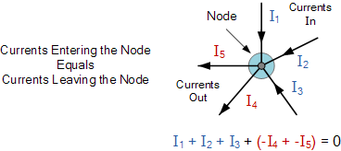

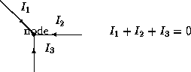

***Kirchhoff’s Second Law (Voltage Law):*** Kirchhoff’s Voltage Law or KVL, states that “in any closed loop network, the total voltage around the loop is equal to the sum of all the voltage drops within the same loop” which is also equal to zero. In other words, the algebraic sum of all voltages within the loop must be equal to zero. This idea by Kirchhoff is known as the Conservation of Energy.

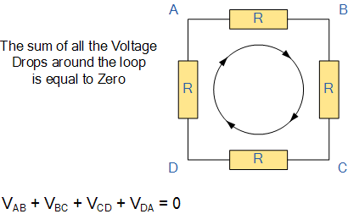

Starting at any point in the loop continue in the same direction noting the direction of all the voltage drops, either positive or negative, and returning back to the same starting point. It is important to maintain the same direction either clockwise or anti-clockwise or the final voltage sum will not be equal to zero. We can use Kirchhoff’s voltage law when analyzing series circuits.

http://www.physics.uoguelph.ca/tutorials/ohm/KVL.gif

Application of Kirchhoff's Laws to Circuits:

The current distribution in various branches of a circuit can easily be found out by applying Kirchhoff Current law at different nodes or junction points in the circuit. After that Kirchhoff Voltage law is applied, each possible loop in the circuit generates algebraic equation for every loop. By solving all these equations, one can easily find out different unknown currents, voltages and resistances in the circuits.

**Development:**

1. Without turning on the power supply, arm the circuit of figure 1 over the protoboard. Once it´s armed proceed to set the values of voltages in the supplies, with the values set in the tables and connect them to the circuit like it´s shown.

|  |  |  |
| --- | --- | --- |
| Element | Value | Power |
| Vs1 | 9V |  |
| Vs2 | 5V |  |
| R1 | 470Ω | ½ watt |
| R2 | 330Ω | ½ watt |
| R3 | 560Ω | ½ watt |

* 1. When entering the laboratory, the student must take solved the circuit, with the theoretical values already calculated, and written down in the column of the results table.

1. Applying Kirchhoff’s law of voltage to this circuit, find theoretically the values of voltage on the marked points.
2. Find the resulting current and describe it graphically with its direction of reference over the circuit diagram.
3. With the next table, help from the result in the incise B, calculate the voltages indicated in the next table, describing graphically its polarity.
4. Check the validity of this calculations with the measurements with the voltmeter and report its theoretical measurements and experiments in table 1.
5. Apply the statement of the voltage law over the results of our measurements realizing the algebraic sum of the voltages. Write the results in the table.
6. Obtain the power of every element in the circuit.
7. Determine the sign of the voltages and powers   
   according to the passive suitability of the signs and through this convention determine which are the elements that supply power and which ones absorb it.

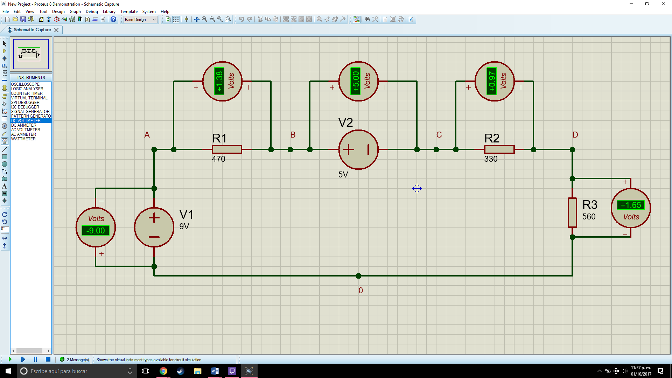

|  |  |  |  |  |  |
| --- | --- | --- | --- | --- | --- |
| Measurements | Theoretical Value (V) | Measured Value (V) | Theoretical Power (milliwatt) | Measured Power (milliwatt) | Absorb/  Supply |
| Voltage V0A | -9 | -9V | -26.46 | -27.21 | S |
| Voltage VAB | 1.38 | 1.34 | 3.77 | 4.06 | A |
| Voltage VBC | 5 | 5 | 14.7 | 13.98 | S |
| Voltage VCD | 0.97 | 0.96 | 2.85 | 2.85 | A |
| Voltage VD0 | 1.65 | 1.70 | 4.83 | 4.15 | A |
|  | ∑V=0 | ∑V=0 | ∑P=-0.31 | ∑P=-2.17 |  |

**II: Testing of the Kirchhoff’s voltage laws.**

Without turning on the power supplies, arm the circuit of figure 2 over the protoboard. Once it´s been armed, proceed to setting the values of voltage indicated for the supplies and connect them to the circuit.

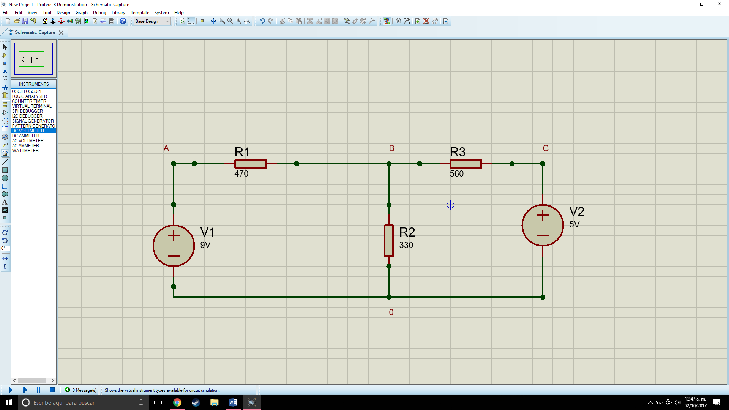

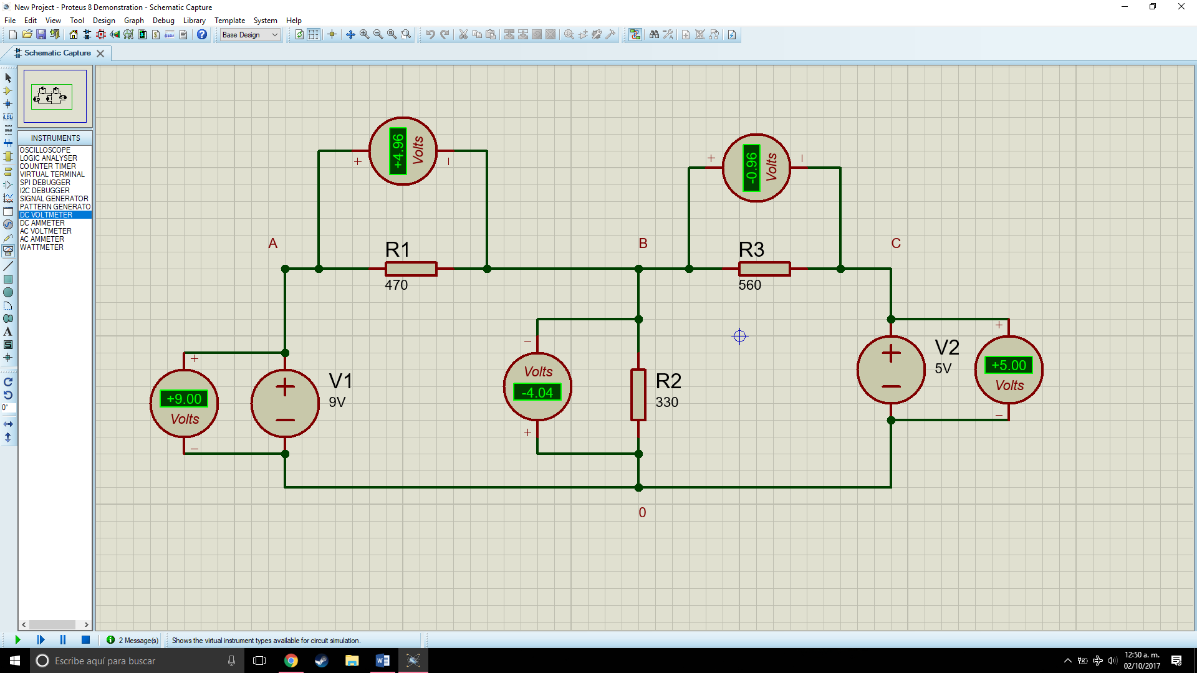

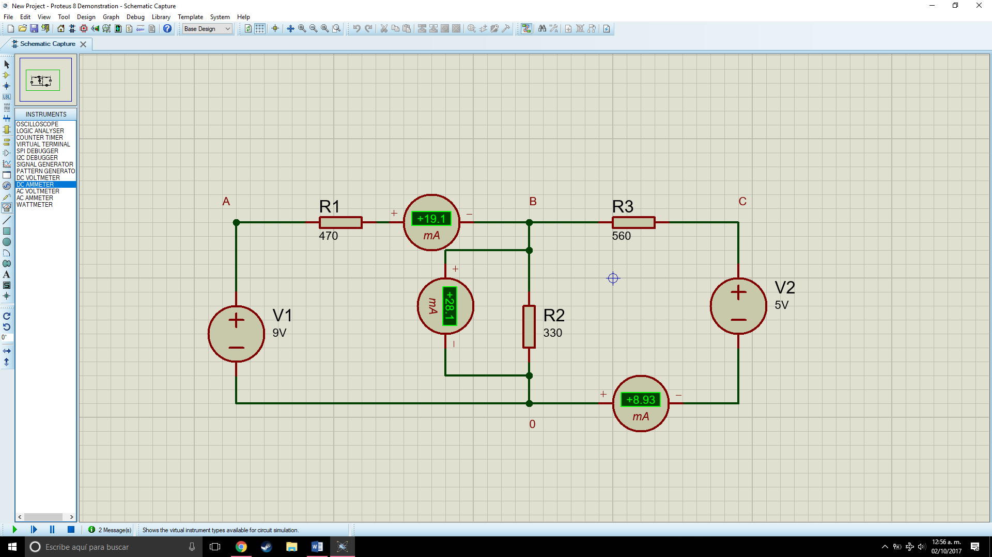

|  |  |  |
| --- | --- | --- |
| Measurements | Theoretical Value(milliamperes) | Measured Value(milliamperes) |
| Current I1 | 19.1 | 18.8 |
| Current I2 | 28.1 | 27.8 |
| Current I3 | 8.93 | 9.2 |

|  |  |  |  |  |  |
| --- | --- | --- | --- | --- | --- |
| Measurements | Theoretical Value (V) | Measured Value (V) | Theoretical Power (milliwatt) | Measured Power (milliwatt) | Absorb/  Supply |
| Voltage V0A | 9 | 9 | 94.9095 | 95.21 | S |
| Voltage VAB | 4.96 | 4.54 | 52.2033 | 52.86 | A |
| Voltage VB0 | -4.04 | -4.27 | - | - | A |
| Voltage VBC | -0.96 | -0.96 | -8.539 | -8.35 | A |
| Voltage VC0 | -5 | -5 | -8.98 | -8.15 | S |
|  | ∑V=0 | ∑V=0. | ∑P=114.67 | ∑P=113.32 |  |

Define what a node is in an electric circuit:

R= It´s the point where a connection is made.

Define what´s an electric circuit:

R=An electric circuit is a path in which [electrons](https://simple.wikipedia.org/wiki/Electrons) from a [voltage](https://simple.wikipedia.org/wiki/Voltage) or [current](https://simple.wikipedia.org/wiki/Electric_current) source flow.

Express in mathematical form Kirchhoff’s current law.

R= $\sum{I}=0$

Define what a closed trajectory is in an electric circuit.

R= A path where the electrons flow and it´s closed in a way that no electron goes outside of it.

Define what´s fall of voltage.

R=The time interval during which the voltage changes from 100% to 0% of its value

**Calculations:**

|  |  |  |  |  |
| --- | --- | --- | --- | --- |
| Voltage formula | Measurements | Resistance | Substitution | Value obtained |
| V=IR | V0A Voltage | 3.006KΩ | V=(2.9411mA)(3.006KΩ) | 9V |
| V=IR | VAB Voltage | 470Ω | V=(2.9411mA)(0.47KΩ) | 1.3823 V |
| V=IR | VBC Voltage | 1.7KΩ | V=(2.9411mA)(1.7KΩ) | 5V |
| V=IR | VCD Voltage | 330Ω | V=(2.9411mA)(0.33KΩ) | 0.9705 V |
| V=IR | VD0 Voltage | 560Ω | V=(2.9411mA)(0.56KΩ) | 1.6470 V |

|  |  |  |  |  |
| --- | --- | --- | --- | --- |
| Potency formula | Measurements | Voltage | Substitution | Value obtained |
| P=VI | P0A Voltage | -9V | P= (-9V)(2.9411mA) | -26.46mW |
| P=VI | PAB Voltage | 1.3823V | P = (1.382V)(2.9411mA) | 3.77mW |
| P=VI | PBC Voltage | 5V | P = (5V)(2.9411mA) | 14.7mW |
| P=VI | PCD Voltage | 0.9705V | P = (0.970V)(2.9411mA) | 2.8528mW |
| P=VI | PD0 Voltage | 1.6470V | P = (1.647V)(2.9411mA) | 4.8439mW |



|  |  |  |  |  |
| --- | --- | --- | --- | --- |
| Potency formula | Measurements | Voltage | Substitution | Value obtained |
| P=VI | P0A Voltage | -9V | P= (-9V)(10.5455mA) | 94.9095mW |
| P=VI | PAB Voltage | 4.9503V | P = (4.9503V)(10.54mA) | 52.2033mW |
| P=VI | PBC Voltage | -0.9563V | P = (5V)(-1.7078mA) | -8.539mW |
| P=VI | PC0 Voltage | 5V | P = (5V)(-1.7978mA) | -8.989mW |

**Conclusions:**

Luis Enrique: The practice shows us the behavior of an electric circuit if we analyze it from the laws of Kirchhoff. It also shows that some electronic circuits can be analyzed in different ways and that ideal concepts should be known for the analysis of them.

Luis Alberto: The first practice is important because we understand the use of the elements as passive and active, also the interaction between these elements.

José Emiliano: After developing this practice, we learned how to calculate a voltage using Kirchhoff’s voltage law and current, how it behaves and the proper mesh analysis to use.

***Bibliography:***

<http://theory.uwinnipeg.ca/physics/curr/node8.html>

<http://www.facstaff.bucknell.edu/mastascu/elessonshtml/basic/basic5kv.html>

<http://ffden-2.phys.uaf.edu/211.fall2000.web.projects/Jeremie%20Smith/page3.html>